Title of Your Abstract (Calibri 14 pt bold centered)

Author(s), Calibri 12 pt plain - centered, if there is more than one author, underline the name of the presenting author, for example: John Doe, Robert Braun, Jeanine White

Affiliation and address, Calibri 12 pt italics - centered, for example:
Laboratoire de Chimie Organique,
Université libre de Bruxelles, Avenue F. D. Roosevelt 50, 1050 Brussels, Belgium
email: mocs2026@ulb.be

Text of your abstract, Calibri 12 pt plain – justified text, single spacing, no indentation. Insert one empty line between paragraphs.

Insert figures, schemes, or structures directly into the text. When drawing structures or schemes with ChemDraw, chose the “ACS Document 1996” style (Arial 10 pt for atom labels). For example, see structures 1, 2 and 3 below. Colors may be used and will appear in the online version of your abstract, but keep in mind that this page will be reduced to half-size and printed in black & white only in the book of abstracts, so make sure that all the illustrations remain legible.

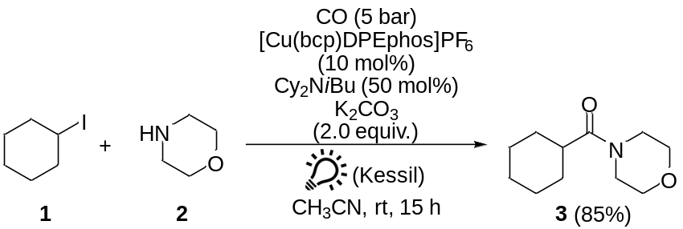

If references are cited, they should be numbered and placed in square brackets after any punctuation mark. Here is an example.[1] The list of references should be located at the end of the abstract after the word References, Calibri 11 pt – justified text, single spacing, no indentation, no empty line between references. Please format the references according to the ACS guidelines as in the examples below [1-4].

Your abstract must fit within a single page. Do not change the margins nor the document settings of this template.

Kindly bear in mind that abstracts will not be proofread and copy-edited, therefore the text and graphics will be reproduced exactly as submitted, including any errors or typos that might be present. The authors are the sole responsible for its content.

References
[1] Hopkinson, M. N.; Richter, C.; Schedler, M.; Glorius, F. Nature 2014, 510, 485.
[2] Flanigan, D. M.; Romanov-Michailidis, F.; White, N. A.; Rovis, T. Chem. Rev. 2015, 115, 9307.
[3] N-Heterocyclic Carbenes: From Laboratory Curiosities to Efficient Synthetic Tools, Díez-González, S., Ed.; Royal Society of Chemistry: Cambridge, 2nd ed., 2017.
[4] Hogarth, G. in Progress in Inorganic Chemistry, Karlin, K. D., Ed.; John Wiley & Sons: Hoboken, 2005, vol. 53, pp. 71-91.

